Hard drive replacement/installation

You may be replacing a hard drive with a higher capacity or better performing hard drive, or are replacing a confirmed dead or otherwise failing hard drive through OEM tools. It is also possible in many cases to install a newer hard disk and use one as a second hard drive provided there are available connections and drive bays.

1: Backup all necessary user files to an external hard drive, thumb drive or use an external hard drive dock to transfer the files to the new hard drive afterward.

2: Power off and unplug the computer remove or open the side panel.

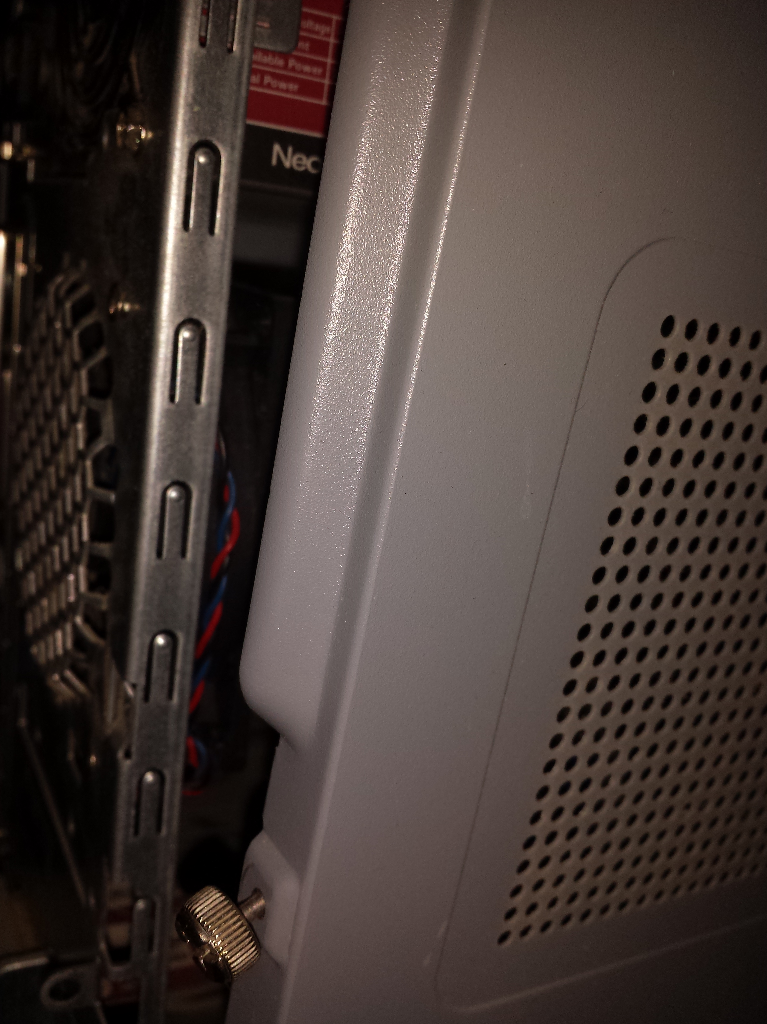

3: If removing the old drive unplug SATA power and data cable from the hard drive and if necessary any screws, and remove the drive from the bay.

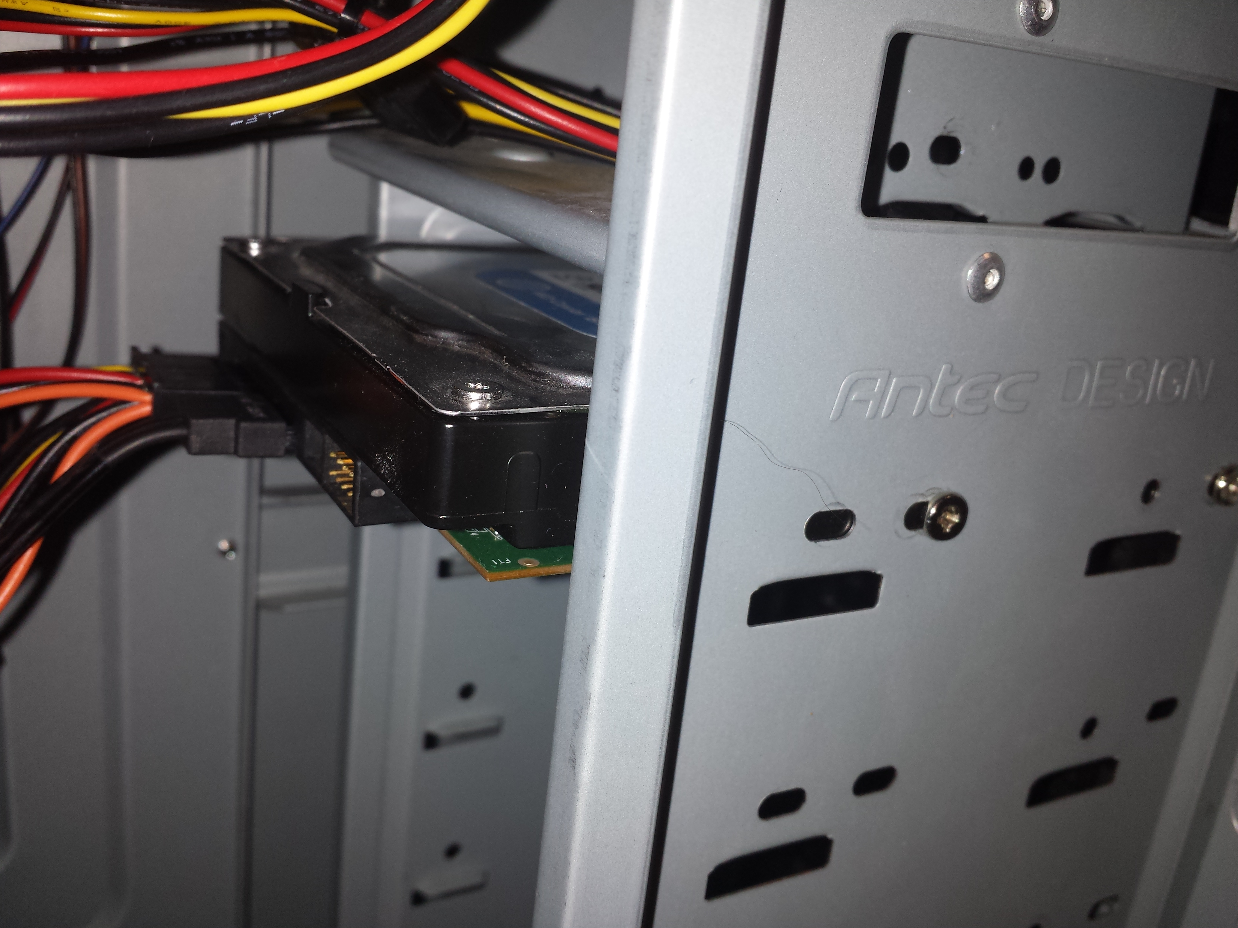

4: Install the new hard drive into an open bay by either using tool-less hardware or using screws.

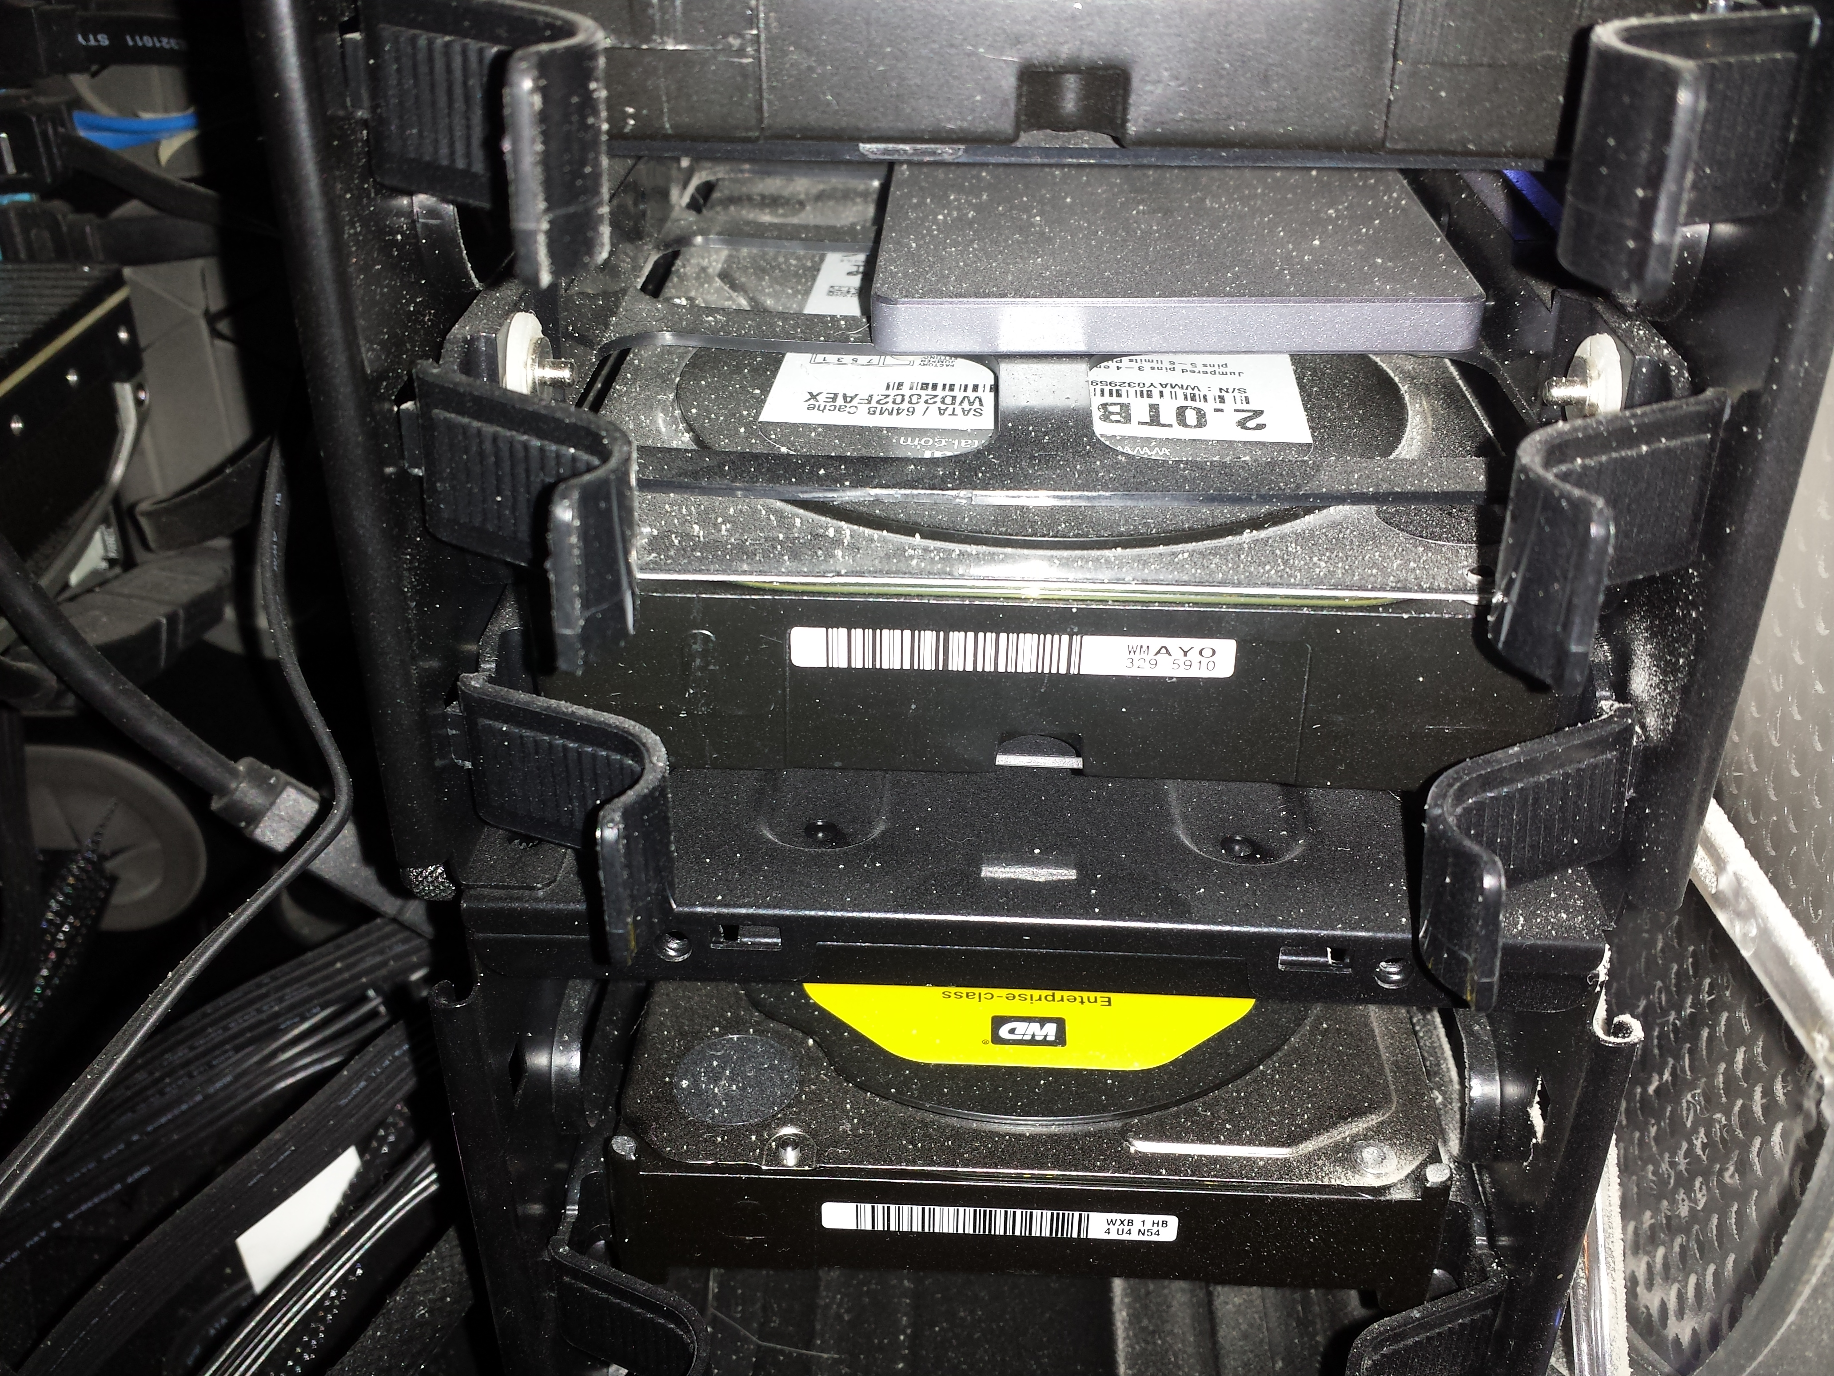

5: Connect the SATA data and power cable to the new drive, or with a supplied or purchased data cable.

6: Replace the side panel, plug in power, and turn on the system.

7: If you are replacing the drive containing the OS proceed to install Windows, and transfer the backed up files to the freshly installed system, and reinstall any necessary software.

8: If adding a second drive navigate to

Control Panel > Administrative tools > Computer Management > Storage > Disk management

and right click the new drive to select formatting options and assign a drive letter.

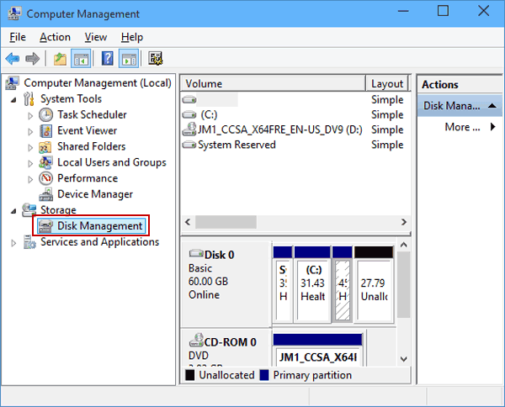

https://www.isunshare.com/windows-10/7-ways-to-open-disk-management-in-windows-10.html